**Support Vector Machines for Text Mining:**

The data points that are used to determine the maximum margins are known as the support vector machines.

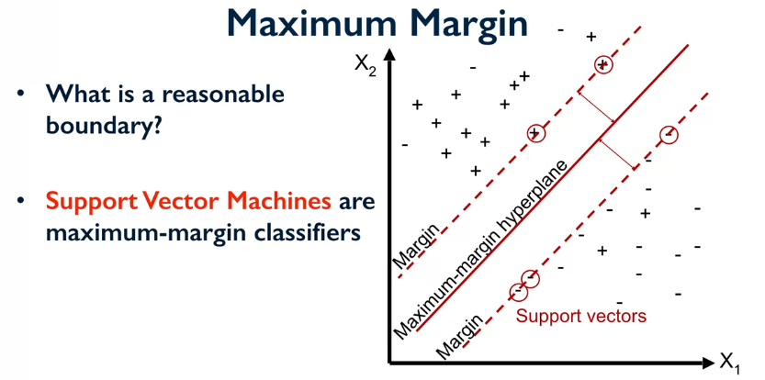

There are two main ways of using SVM’s to do multi-class classification:

* One vs Rest
* One vs One

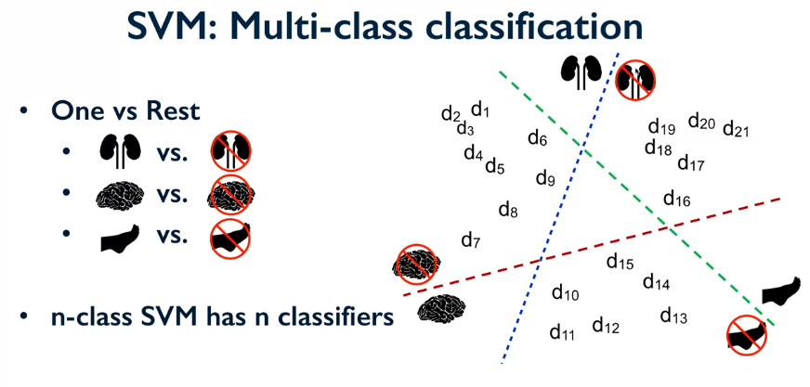

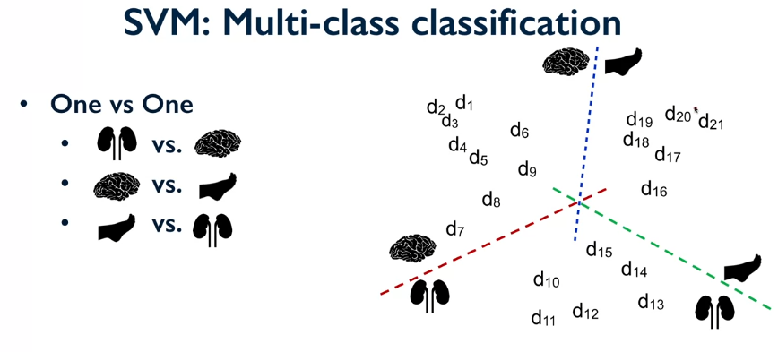

**Parameters:**

**C –** this is a regularization penalty. For large values of C there is less regularization and therefore the model doesn’t generalize as well. With small values of C there is more regularization and the model will generalize better to new data instances.

**Multi_class** **–** this is used to define if we use one v one or one v rest models.